STATUS UPDATE

(WEBSITE)

**User Authentication & Security for a System :**

1. **Username and Password Authentication**

This security method of user authentication requires users to input their credentials (such as a username and password) in order to access the system.

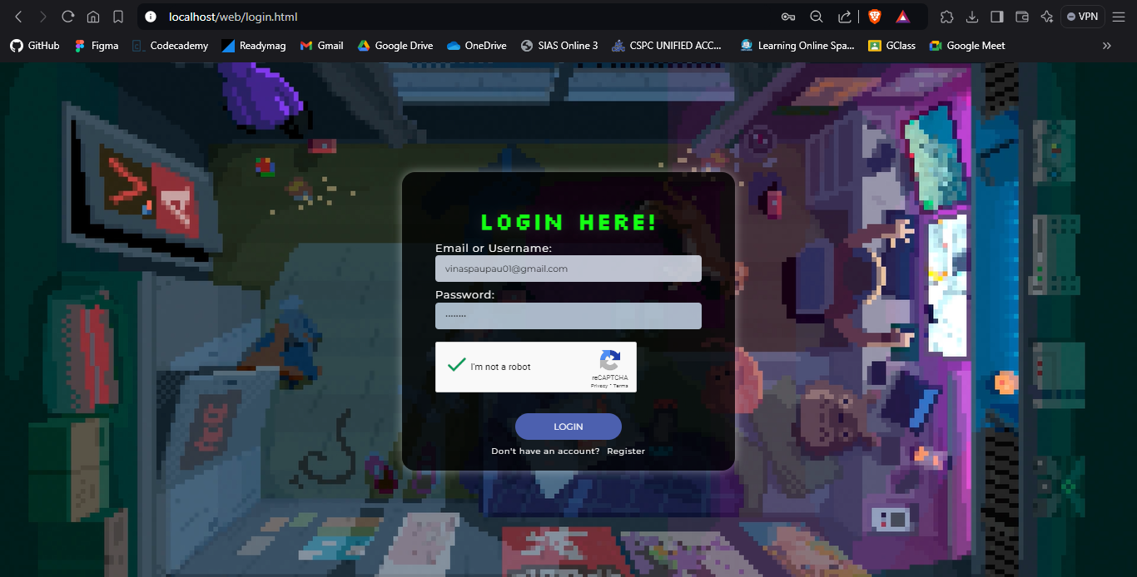

When creating an account, the username and password should not be duplicated; otherwise, the account cannot be created. Also, the password should have 8 characters and at least one number.

1. **Account Lockout Mechanism**

This security feature locks an account for 15 minutes after 5 failed login attempts to prevent unauthorized access.

After a 5 failed login attempts

1. **Captcha or reCAPTCHA Integration**

This security feature will protect users from bots by asking them to complete challenges (such as picture selection) upon login or registration.

* For Register :

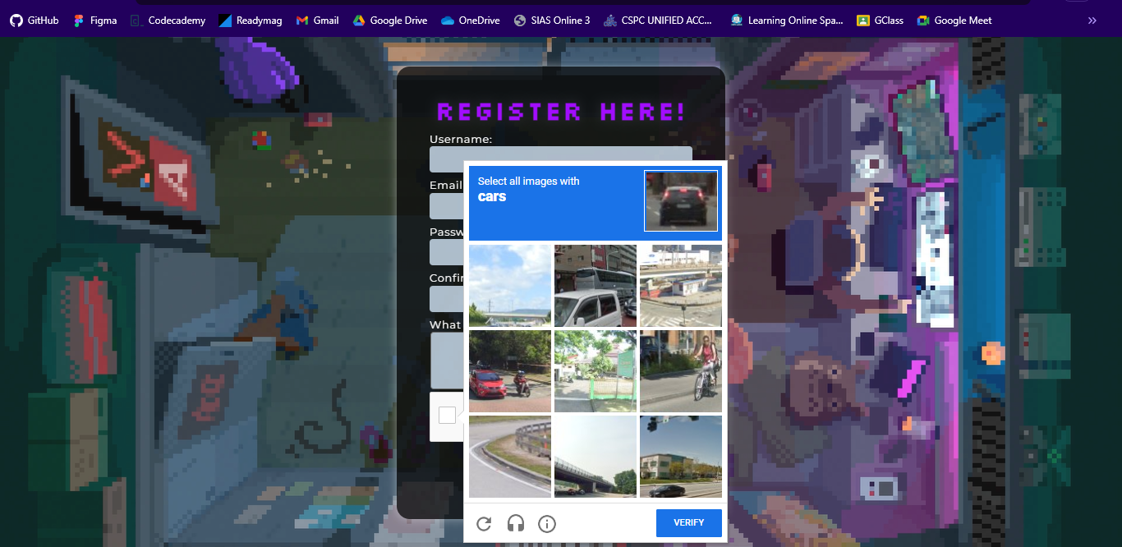

* For Log In :

1. **Session Management and Timeout**

This security feature efficiently manages user sessions, including auto-logout after 3 minutes of inactivity for better security.

Before the session expires (approximately 3 minutes), an alert pop-up appears (in 30 seconds, it will automatically log out).

**The database we used :**

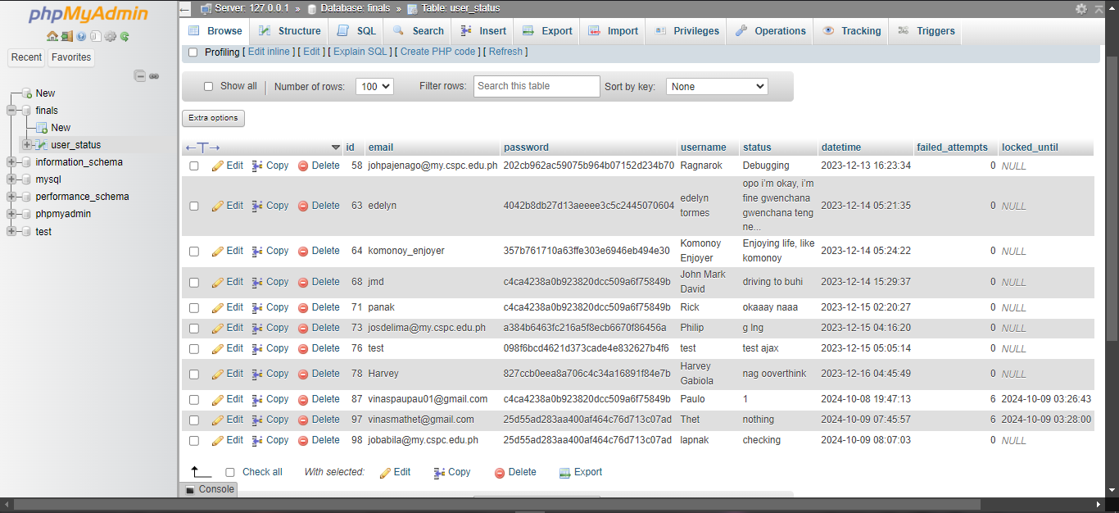

**Group Member :**

|  |  |
| --- | --- |
|  | Judah Paulo Viñas |
|  | Roland Joseph Cordez |
|  | John Rick Babila |